Q1.
A block-level element always starts on a new line and takes up the full width available (stretches out to the left and right as far as it can).
For example: <div> , <h1-h6> , <canvas> , <article> etc.

An inline element does not start on a new line and only takes up as much width as necessary.
For example: <span>, <input> , <img> , <a> etc.

Q2.
Display: none , is commonly used with JavaScript to hide and show elements without deleting and recreating them.
Visibility: hidden also hides an element. However, the element will still take up the same space as before. The element will be hidden, but still affect the layout:

Q3.
The Float property is used for positioning and formatting content e.g. let an image float left to the text in a container.
The Clear property specifies what elements can float beside the cleared element and on which side.

Q4.
Static: An element with position: static is not positioned in any special way; it is always positioned according to the normal flow of the page.
Relative: An element with position: relative is positioned relative to its normal position.Setting the top, right, bottom, and left properties of a relatively-positioned element will cause it to be adjusted away from its normal position.
Fixed: An element with position: fixed is positioned relative to the viewport, which means it always stays in the same place even if the page is scrolled. The top, right, bottom, and left properties are used to position the element.
Absolute: An element with position: absolute is positioned relative to the nearest positioned ancestor (instead of positioned relative to the viewport, like fixed).

Q5.
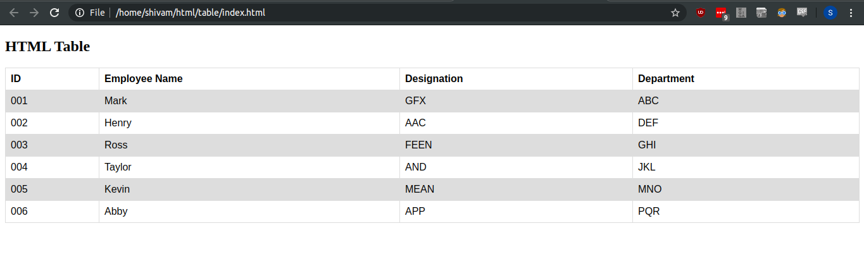
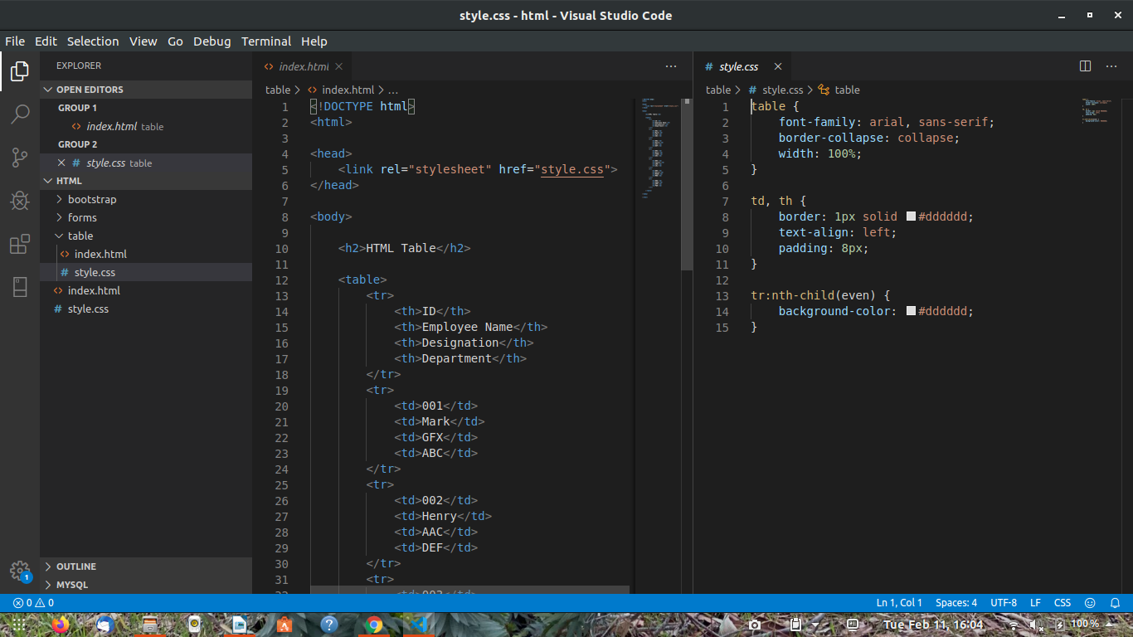

Source Code :-

HTML --
<!DOCTYPE html>
<html>

<head>
<link rel="stylesheet" href="style.css">
</head>

<body>

<h2>HTML Table</h2>

<table>
<tr>
<th>ID</th>
<th>Employee Name</th>
<th>Designation</th>
<th>Department</th>
</tr>
<tr>
<td>001</td>
<td>Mark</td>
<td>GFX</td>
<td>ABC</td>
</tr>
<tr>
<td>002</td>
<td>Henry</td>
<td>AAC</td>
<td>DEF</td>
</tr>
<tr>
<td>003</td>
<td>Ross</td>
<td>FEEN</td>
<td>GHI</td>
</tr>
<tr>
<td>004</td>
<td>Taylor</td>
<td>AND</td>
<td>JKL</td>
</tr>
<tr>
<td>005</td>
<td>Kevin</td>
<td>MEAN</td>
<td>MNO</td>
</tr>
<tr>
<td>006</td>
<td>Abby</td>
<td>APP</td>
<td>PQR</td>
</tr>

</table>

</body>

</html>

CSS--
table {
font-family: arial, sans-serif;
border-collapse: collapse;
width: 100%;
}

td, th {
border: 1px solid #dddddd;
text-align: left;
padding: 8px;
}

tr:nth-child(even) {
background-color: #dddddd;
}

Q6.
The <meta> tag provides metadata about the HTML document. Metadata will not be displayed on the page, but will be machine parsable. Meta elements are typically used to specify page description, keywords, author of the document, last modified, and other metadata.

Q7.
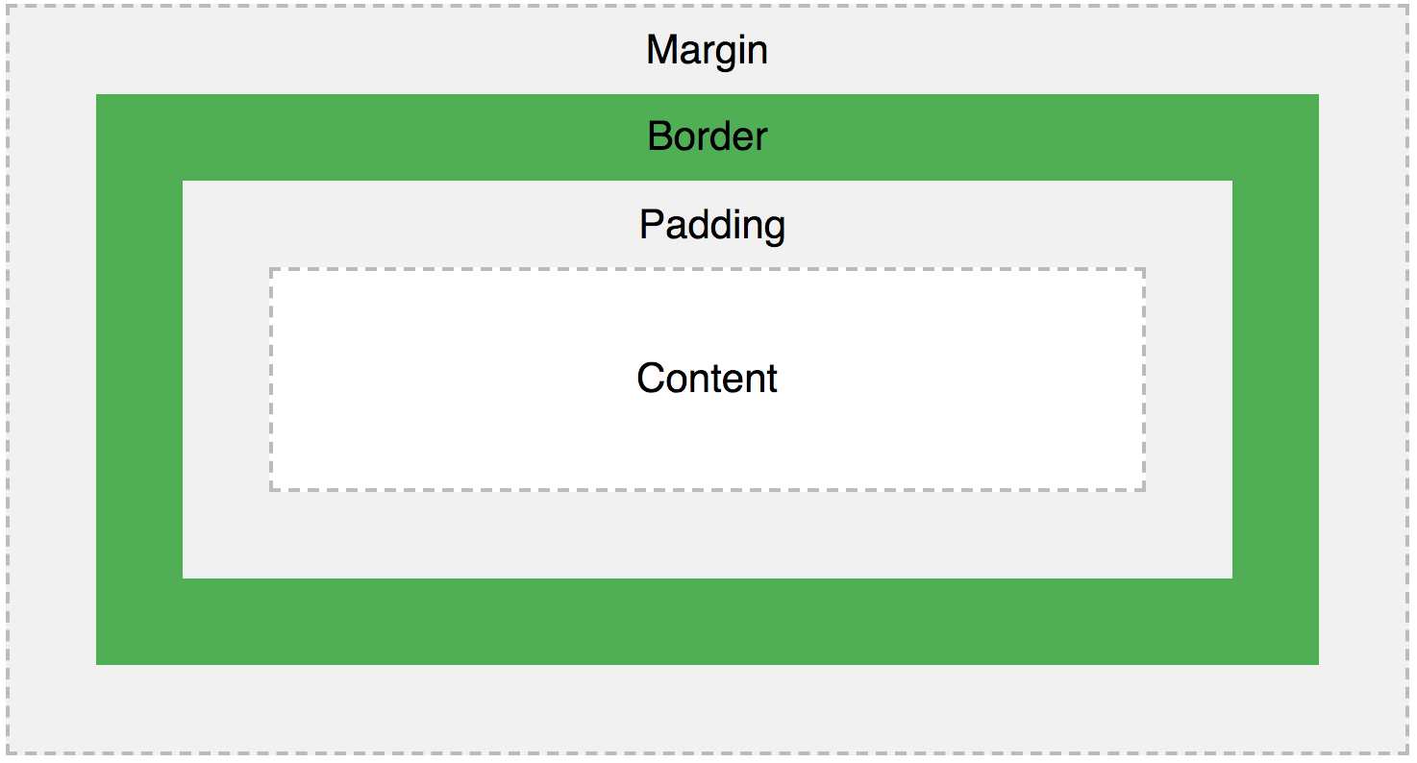
All HTML elements can be considered as boxes. In CSS, the term "box model" is used when talking about design and layout.
Explanation of the parts in box model:
- Content - The content of the box, where text and images appear
- Padding - Clears an area around the content. The padding is transparent
- Border - A border that goes around the padding and content
- Margin - Clears an area outside the border. The margin is transparent

Q8.
The different CSS Selectors are:
- Id Selector:The id selector uses the id attribute of an HTML element to select a specific element. The id of an element is unique within a page, so the id selector is used to select one unique element!
- Class Selector: The class selector selects HTML elements with a specific class attribute. To select elements with a specific class, write a period (.) character, followed by the class name.
- Universal Selector (*): The universal selector (*) selects all HTML elements on the page
Grouping Selector: The grouping selector selects all the HTML elements with the same style definitions.

Q9.
The <!DOCTYPE> declaration is not an HTML tag; it is an instruction to the web browser about what version of HTML the page is written in.
In HTML 4.01, the <!DOCTYPE> declaration refers to a DTD, because HTML 4.01 was based on SGML. The DTD specifies the rules for the markup language, so that the browsers render the content correctly. HTML5 is not based on SGML, and therefore does not require a reference to a DTD. We must always add the <!DOCTYPE> declaration to your HTML documents, so that the browser knows what type of document.

Q10.
Semantic tags used in HTML are:
- <article> : The <article> element specifies independent, self-contained content. An article should make sense on its own, and it should be possible to read it independently from the rest of the web site.
- <header> : The <header> element specifies a header for a document or section.The <header> element should be used as a container for introductory content.
- <footer> : The <footer> element specifies a footer for a document or section. A <footer> element should contain information about its containing element.
- <nav>: The <nav> element defines a set of navigation links.
- <aside>: The <aside> element defines some content aside from the content it is placed in (like a sidebar). The <aside> content should be related to the surrounding content.

Q11.
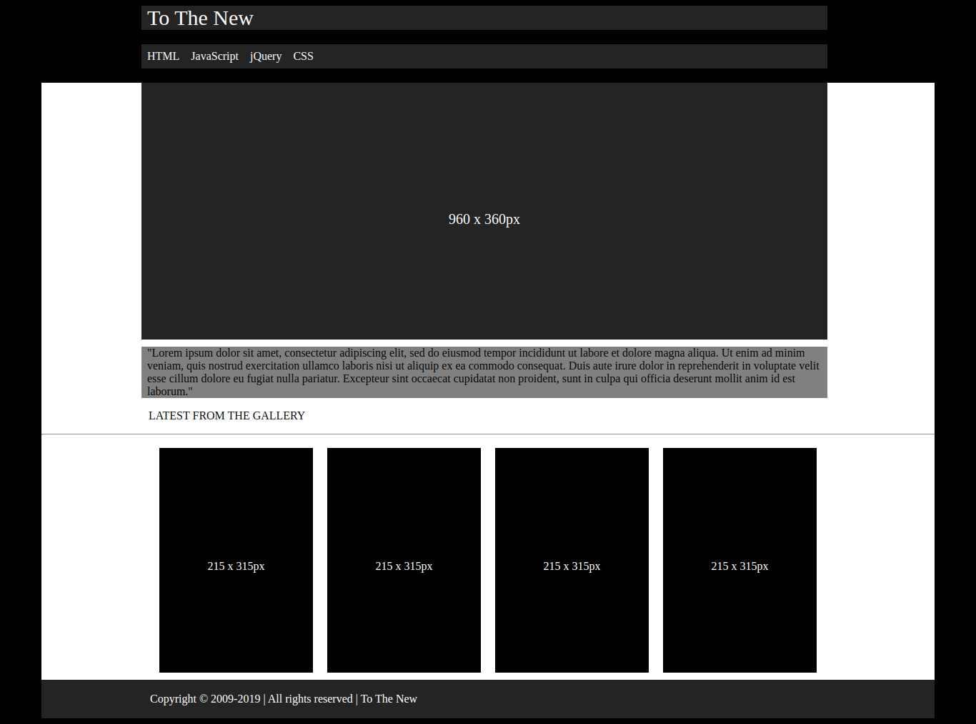

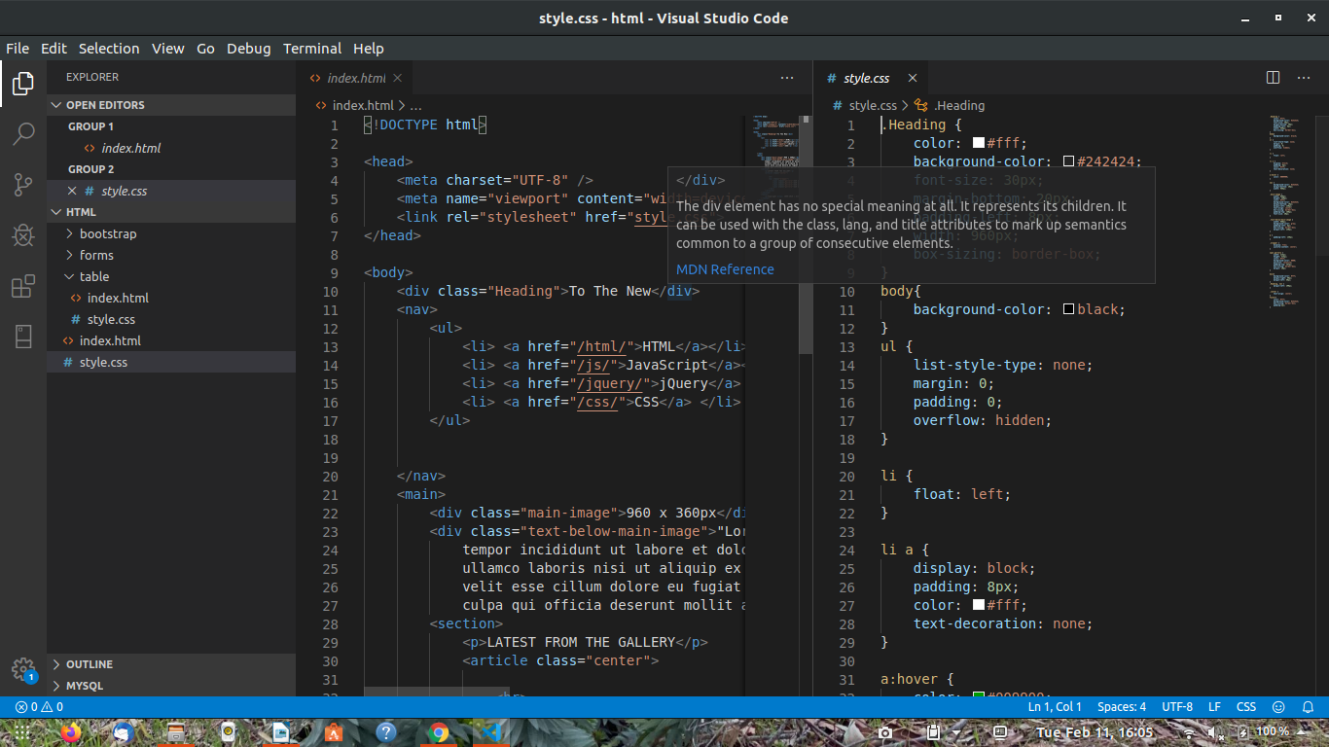

Source Code:-

HTML --
<!DOCTYPE html>

<head>
<meta charset="UTF-8" />
<meta name="viewport" content="width=device-width,initial-scale=1.0">
<link rel="stylesheet" href="style.css">
</head>

<body>
<div class="Heading">To The New</div>
<nav>
<ul>
<li> <a href="/html/">HTML</a></li>
<li> <a href="/js/">JavaScript</a></li>
<li> <a href="/jquery/">jQuery</a> </li>
<li> <a href="/css/">CSS</a> </li>
</ul>

</nav>
<main>
<div class="main-image">960 x 360px</div>
<div class="text-below-main-image">"Lorem ipsum dolor sit amet, consectetur adipiscing elit, sed do eiusmod
tempor incididunt ut labore et dolore magna aliqua. Ut enim ad minim veniam, quis nostrud exercitation
ullamco laboris nisi ut aliquip ex ea commodo consequat. Duis aute irure dolor in reprehenderit in voluptate
velit esse cillum dolore eu fugiat nulla pariatur. Excepteur sint occaecat cupidatat non proident, sunt in
culpa qui officia deserunt mollit anim id est laborum."</div>
<section>
<p>LATEST FROM THE GALLERY</p>
<article class="center">

<hr>
<div class="wrapper">
<span class="gallery">215 x 315px</span>
<span class="gallery">215 x 315px</span>
<span class="gallery">215 x 315px</span>
<span class="gallery">215 x 315px</span>
</div>
</article>
</section>
<footer>
<p>Copyright &copy; 2009-2019 | All rights reserved | To The New<p>
</footer>
</main>

</body>

CSS--
.Heading {
color: #fff;
background-color: #242424;
font-size: 30px;
margin-bottom: 20px;
padding-left: 8px;
width: 960px;
box-sizing: border-box;
}
body{
background-color: black;
}
ul {
list-style-type: none;
margin: 0;
padding: 0;
overflow: hidden;
}

li {
float: left;
}

li a {
display: block;
padding: 8px;
color: #fff;
text-decoration: none;
}

a:hover {
color: #009900;
}

nav {
background-color: #242424;
margin-bottom: 20px;
width: 960px;
}

.main-image {
width: 960px;
height: 360px;
color: #fff;
background-color: #242424;
margin-bottom: 10px;
margin-left: 140px;
text-align: center;
box-sizing: border-box;
padding-top: 180px;
font-size: 20px;
}

.text-below-main-image {
width: 960px;
background-color: grey;
padding-left: 8px;
box-sizing: border-box;
margin-left: 140px;
}

p {
padding-left: 150px;
}

.wrapper {
display: flex;
justify-content: center;
}

span.gallery {
width: 215px;
height: 315px;
color: #fff;
background-color: #000;
position: relative;
padding-top: 157px;
box-sizing: border-box;
margin: 10px;
}

main{
background-color: #fff;
margin-right: 50px;
margin-left: 50px;
}
.Heading, nav {
margin-left: 190px;
}

.center {
text-align: center;
}
footer{
color: #fff;
background-color: #242424;
box-sizing: border-box;
padding:2px;
}

Q12.
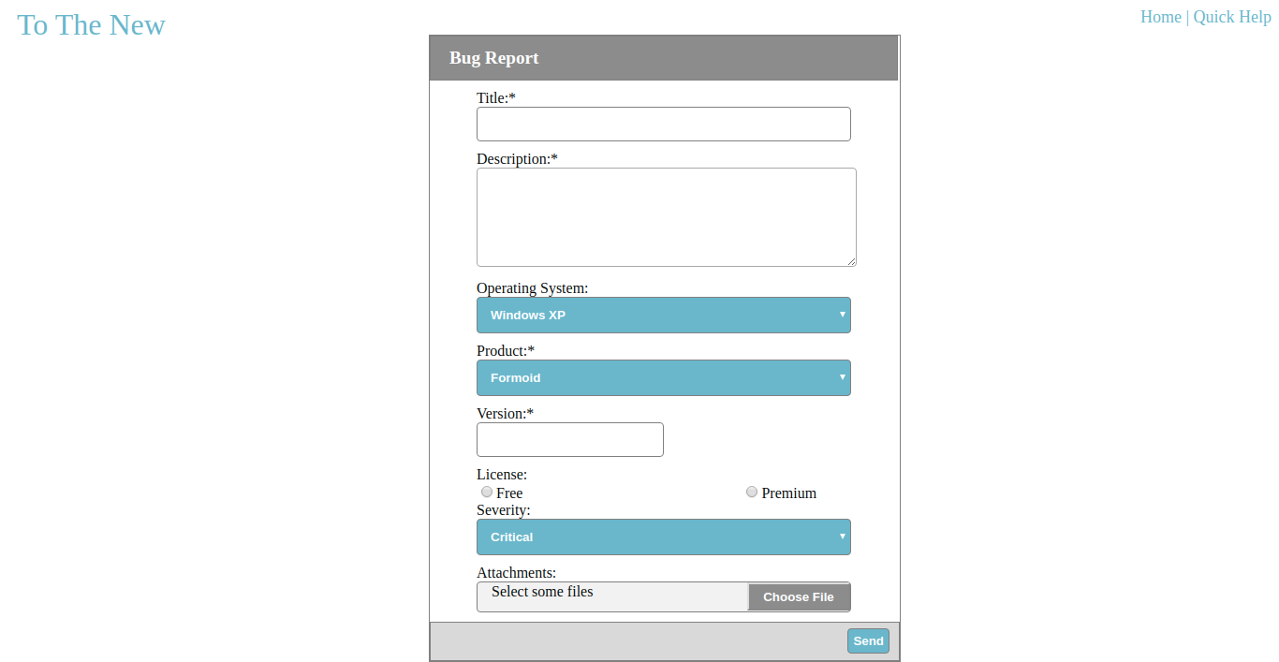

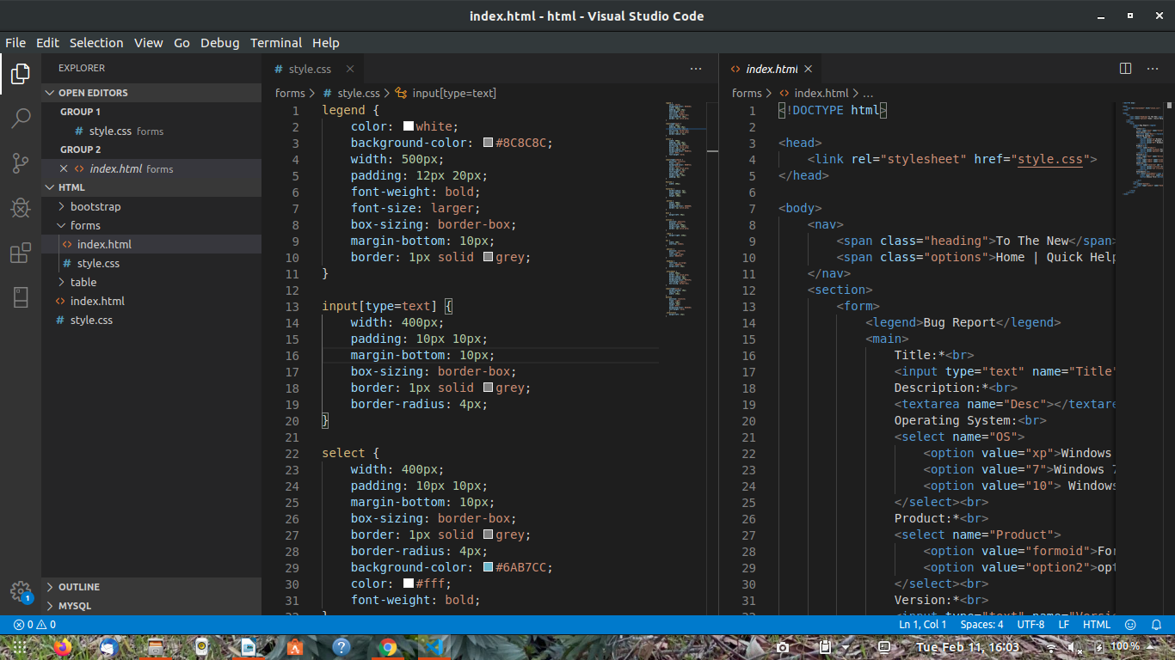

Source Code :-

HTML--
<!DOCTYPE html>

<head>
<link rel="stylesheet" href="style.css">
</head>

<body>
<nav>
<span class="heading">To The New</span>
<span class="options">Home | Quick Help</span>
</nav>
<section>
<form>
<legend>Bug Report</legend>
<main>
Title:*<br>
<input type="text" name="Title"><br>
Description:*<br>
<textarea name="Desc"></textarea><br>
Operating System:<br>
<select name="OS">
<option value="xp">Windows XP</option>
<option value="7">Windows 7</option>
<option value="10"> Windows 10</option>
</select><br>
Product:*<br>
<select name="Product">
<option value="formoid">Formoid</option>
<option value="option2">option</option>
</select><br>
Version:*<br>
<input type="text" name="Version" id="ver123"><br>
License:<br>
<input type="radio" name="license" value="Free"><span class="radio">Free</span>
<input type="radio" name="license" value="Premium">Premium<br>
Severity:<br>
<select name="severity" id="">
<option value="critical">Critical</option>
<option value="not cricitcal">Option2</option>
</select><br>
Attachments:<br>
<div class="attachment"><span class="selections">Select some files</span>
<input type="file" name="upload file">
<button>Choose File</button>

</div>
</main>
<div class="bottom">
<input type="submit" name="Send" value="Send" class="files">
</div>

</form>
</section>
</body>

CSS--
legend {
color: white;
background-color: #8C8C8C;
width: 500px;
padding: 12px 20px;
font-weight: bold;
font-size: larger;
box-sizing: border-box;
margin-bottom: 10px;
border: 1px solid grey;
}

input[type=text] {
width: 400px;
padding: 10px 10px;
margin-bottom: 10px;
box-sizing: border-box;
border: 1px solid grey;
border-radius: 4px;
}

select {
width: 400px;
padding: 10px 10px;
margin-bottom: 10px;
box-sizing: border-box;
border: 1px solid grey;
border-radius: 4px;
background-color: #6AB7CC;
color: #fff;
font-weight: bold;
}

input[type=submit] {
position: relative;
float: right;
background-color: #6AB7CC;
color: white;
border: 1px solid grey;
border-radius: 4px;
font-weight: bold;
margin-top: 6px;
margin-right: 10px;
padding: 5px;
}

#ver123 {
width: 200px;
}

textarea {
border-radius: 4px;
margin-bottom: 10px;
width: 400px;
height: 100px;
}

.bottom {
width: 500px;
height: 40px;
background-color: #D9D9D9;
border: 1px solid grey;
}

main {
margin-left: 50px;
}

section {
position: absolute;
display: block;
margin-left: 450px;
margin-right: 549px;
border: 1px solid grey;
}

.radio {
margin-right: 230px;
}

nav {
width: 100%;
overflow: hidden;
}

.options {
position: relative;
float: right;
font-size: large;
color: #6AB7CC;
}

.heading {
font-size: xx-large;
color: #6AB7CC;
margin-left: 10px;
}

.attachment {
width: 400px;
border: 1px solid grey;
border-radius: 4px;
margin-bottom: 10px;
background-color: #F2F2F2;
font-weight:lighter;
box-sizing: border-box;
}

input[type=file] {
margin-bottom: 10px;
opacity: 0%;
width: 150px;
}
button{
position: relative;
float: right;
width: 110px;
height: 30px;
color: #fff;
background-color: #8C8C8C;
font-weight: bold;
}
.selections{
margin-left: 15px;
}

